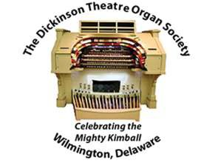
2018-2019 CONCERT SEASON
Individual Concert Ticket Mail Order
DTOS Tickets
P.O. Box 5094 Wilmington DE 19808-0094

Please select the concerts you want to attend and the number of tickets. Return this form to the DTOS Ticket Office with your check. Reserved seating is no longer offered.

CONCERTS - Saturdays at 7 PM |  | NUMBER OF CONCERT TICKETS  At $18.00 each, $10 under age 21 |  |  | AMOUNT
September 22, 2018 Alex Jones
November 17, 2018 Carol Williams
January 26, 2019 Nathan Avakian
March 16, 2019 Richard Hills
April 27, 2019 Phil Kelsall
June 15, 2019 Ken Double
Please print the following information: Total enclosed:
NAME:
ADDRESS:
CITY: | STATE: |  |  | ZIP:
E-MAIL ADDRESS: |  |  | PHONE:
We do not give out or sell our mailing list or telephone numbers. This information is confidential and is for the use of DTOS only. Please make checks payable to Dickinson Theatre Organ Society, Inc. and mail to: DTOS Tickets, P.O. Box 5094, Wilmington DE 19808-0094.
Mail orders must be received the day prior to the concert.
No tickets will be mailed - they will be held for pick-up in the lobby starting at 5:30 p.m. on concert night.
All ticket sales are final. No refunds or exchanges. No phone orders.
Questions? Call the DTOS ticket info line 302-995-5630

