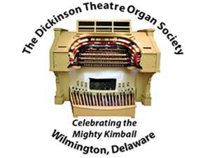
2018-2019 CONCERT SEASON
Season Ticket Mail Order

DTOS Tickets
P.O. Box 5094 Wilmington DE 19808-0094

Please indicate how many SEASON tickets you want and return this form to DTOS at the address shown along with your check. Please note: reserved seating is no longer offered. Ordering Season Tickets is a great benefit as you receive a discounted price! Mail orders must be received by September 21.

6 CONCERT SEASON  Saturdays at 7 pm |  | NUMBER OF SEASON TICKETS At $66 per person $40 per person under age 21 |  |  | TOTAL AMOUNT
2018-2019 Season Ticket**
Please print the following information:
NAME:
ADDRESS:
CITY: | STATE: |  |  | ZIP:
E-MAIL ADDRESS: |  |  | PHONE:
We do not give out or sell our mailing list or any telephone numbers. This information is confidential and is for DTOS use only. Please make checks payable to Dickinson Theatre Organ Society, Inc. and mail to: DTOS Tickets, P.O. Box 5094, Wilmington DE 19808-0094.
Tickets are not mailed – they will be held for pick-up in the lobby starting at 5:30 p.m. at the first concert of the season, September 22, 2018.
All sales are final. No refunds or exchanges. No phone orders are accepted.
Questions? Call the DTOS ticket info line at 302-995-5630.
**Concerts:
September 22, 2018 Alex Jones – November 17, 2018 Carol Williams - January 26, 2019 Nathan Avakian
March 16, 2019 Richard Hills - April 27, 2019 Phil Kelsall - June 15, 2019 Ken Double

